K-Means Clustering Results
Generated: 2026-05-27 19:18:31

Parameters
Index | Parameter | Value
0 | Number of Clusters | 3
1 | Max Iterations | 300
2 | Random State | 42
3 | Standardized | True
4 | Variables Used | Price, Quality, YoungAppeal, Luxury, Distribution, Innovation
5 | Observations | 24

Cluster Sizes
Index | Cluster | Count | Percentage
0 | 0 | 5 | 20.8%
1 | 1 | 11 | 45.8%
2 | 2 | 8 | 33.3%

Fit Measures
Index | Metric | Value | Interpretation
0 | Silhouette Score | 0.42148940087846887 | Closer to 1 is better
1 | Davies-Bouldin Index | 0.7204270719151347 | Lower is better
2 | Calinski-Harabasz Score | 29.083866757218686 | Higher is better

Cluster Centers
Index | Price | Quality | YoungAppeal | Luxury | Distribution | Innovation
Cluster 0 | 0.2525699562218032 | 0.4727334955966628 | 0.8554903739425651 | 0.2974422113812313 | 1.0095346512058527 | 1.0620680699151772
Cluster 1 | -0.9406739314402583 | -0.9121864039466253 | 0.5316369592633455 | -0.941240118817851 | 0.3707745446246946 | 0.11511109275076085
Cluster 2 | 1.1355704330917287 | 0.958797870678697 | -1.2656823027012032 | 1.1083037812612755 | -1.1407741558626148 | -0.8220702962292833

Cluster Assignments
Index | Price | Quality | YoungAppeal | Luxury | Distribution | Innovation | Cluster
0 | 95 | 98 | 65 | 99 | 85 | 75 | 2
1 | 85 | 92 | 70 | 90 | 88 | 80 | 2
2 | 35 | 70 | 85 | 20 | 95 | 85 | 1
3 | 60 | 78 | 75 | 65 | 90 | 70 | 1
4 | 80 | 90 | 95 | 85 | 100 | 98 | 0
5 | 65 | 85 | 88 | 60 | 98 | 90 | 0
6 | 70 | 82 | 85 | 70 | 92 | 95 | 0
7 | 55 | 80 | 90 | 45 | 85 | 92 | 1
8 | 45 | 75 | 92 | 30 | 88 | 90 | 1
9 | 75 | 88 | 72 | 80 | 85 | 82 | 2
10 | 78 | 89 | 70 | 82 | 80 | 85 | 2
11 | 50 | 78 | 88 | 45 | 90 | 80 | 1
12 | 70 | 85 | 95 | 75 | 98 | 88 | 0
13 | 65 | 82 | 93 | 68 | 97 | 86 | 0
14 | 50 | 75 | 90 | 50 | 92 | 82 | 1
15 | 55 | 78 | 88 | 55 | 88 | 85 | 1
16 | 92 | 85 | 60 | 98 | 75 | 65 | 2
17 | 90 | 84 | 58 | 96 | 73 | 68 | 2
18 | 95 | 86 | 55 | 99 | 78 | 60 | 2
19 | 98 | 88 | 50 | 100 | 70 | 55 | 2
20 | 40 | 70 | 90 | 35 | 95 | 85 | 1
21 | 30 | 65 | 92 | 25 | 98 | 80 | 1
22 | 35 | 72 | 85 | 30 | 95 | 75 | 1
23 | 40 | 68 | 80 | 28 | 93 | 70 | 1

Visualizations
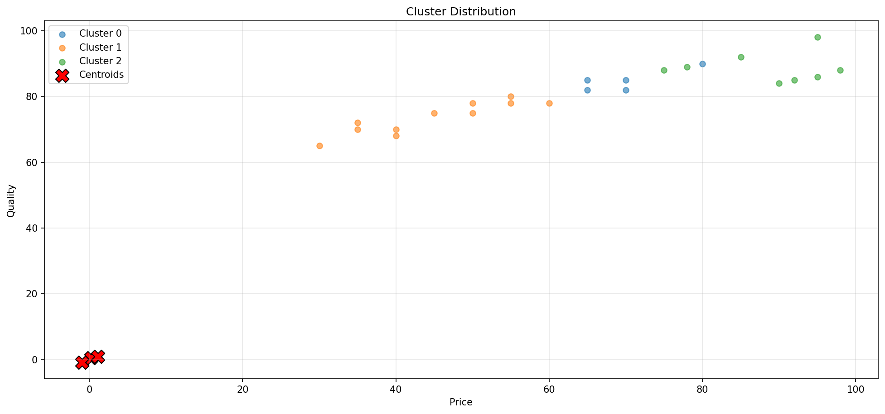
Figure 1

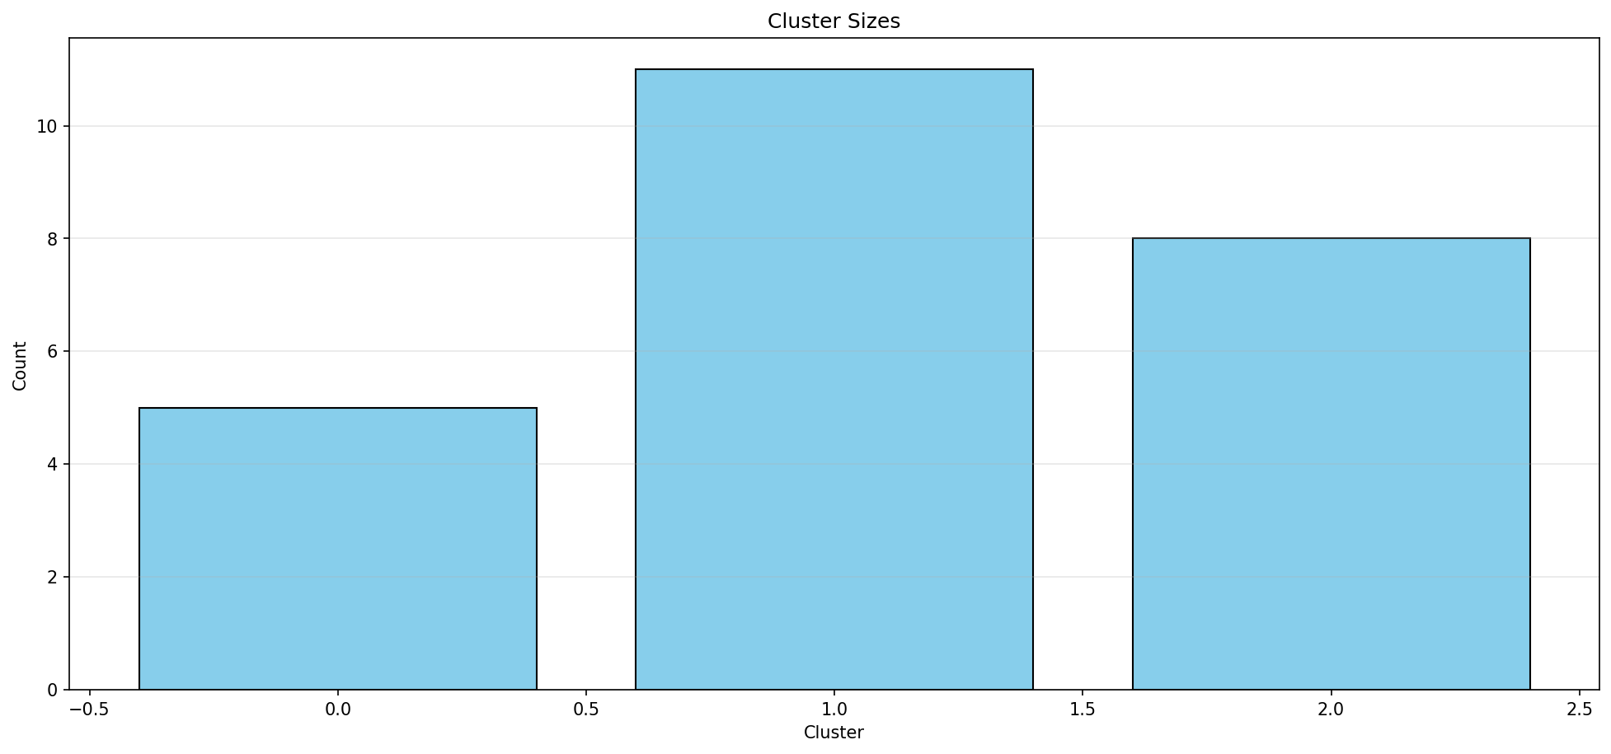
Figure 2

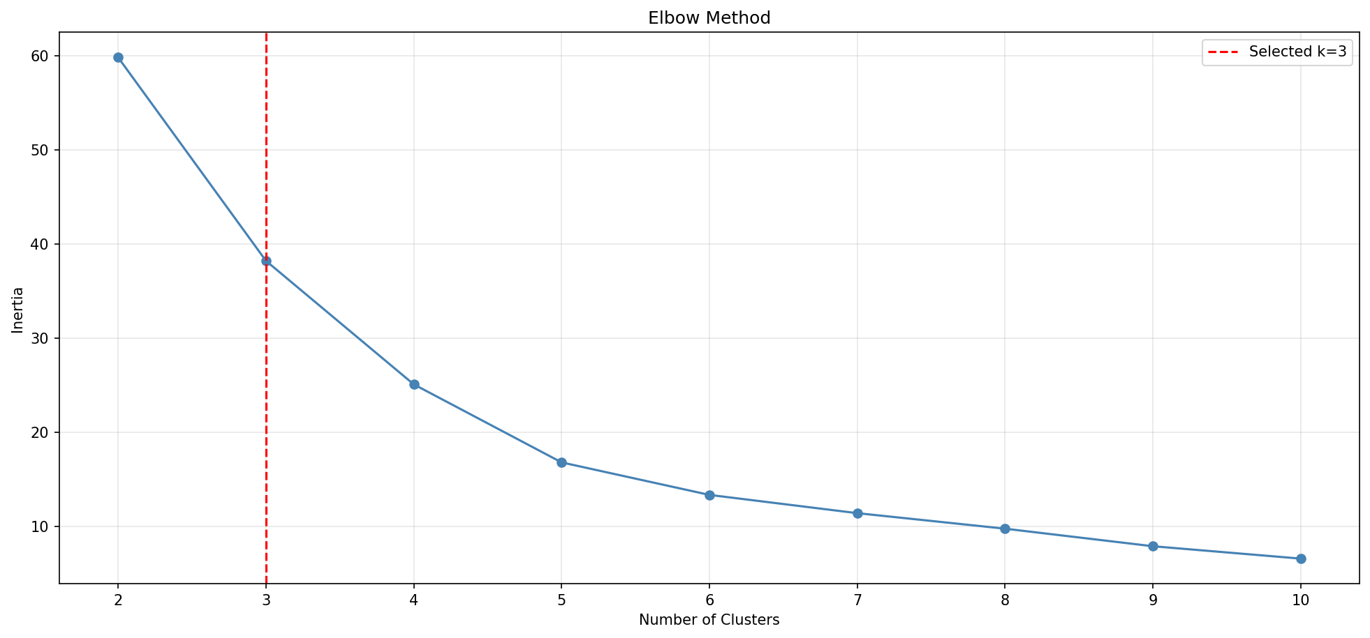
Figure 3

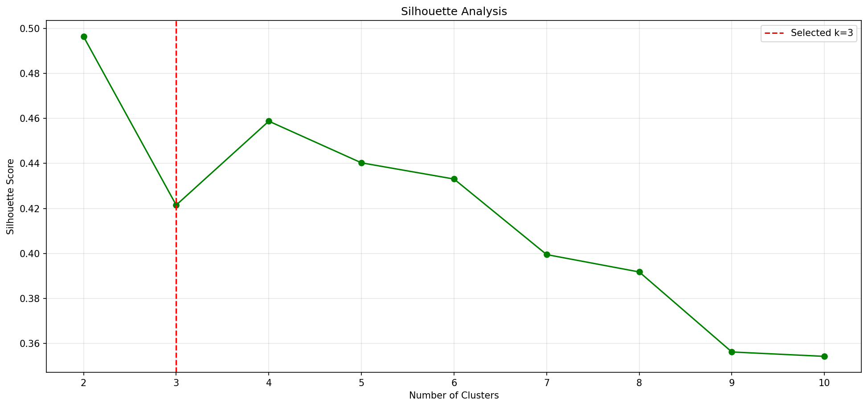
Figure 4

